**Westminster Presbyterian Church**

is called by God to be an inclusive community of faith,

abiding in God’s love, and committed to:

Enjoying God, Following Jesus, and Growing Disciples

**You Are Welcome Here:**

We are glad you are worshipping with us today. Westminster is a welcoming and inclusive community seeking to grow in faith and understanding and to show God’s love to those among us and those around us. We pray you experience our joyful welcome and God’s peaceful presence as you worship with us today.

Questions about Westminster? Just ask! Any one of us would be glad to help.

**The Sanctuary is a Place of Reverence and Worship**

In order that our worship might be meaningful to all, please enter the sanctuary reverently. The narthex or courtyard are good places to visit with friends before or after worship. Use the moments before worship to prepare your heart, mind, and body for worship, centering yourself in the space and quieting your heart. It may be helpful to listen quietly to the prelude, find the hymns we will be singing, meditate on the scriptures we will be reading.

**Children at Westminster:**

Children are an integral part of our church family. We are glad when they come to worship God with us. In our midst, children learn our rhythms of worship, become knit into our fellowship, and teach us as surely as we are teaching them.

Please take children to the restroom before worship. If you need to leave the sanctuary during worship, please use the exits at the rear of the sanctuary. Please avoid walking through the courtyard during worship. We ask that families sit together during worship. Please do not let any child move unaccompanied through the building.

After the “Time with All God’s Children”, children first grade and up (by age or development) are encouraged to remain in worship. Children in kindergarten and younger (by age or development) may depart with our caregivers and teachers for Children’s Sunday School or remain with their parents for worship if they choose.

If this is your first visit to Westminster, you are welcome to accompany your child to Children’s Sunday School so that you can meet our caregivers and help settle your child in. Children’s worship packets are available in the narthex. As is a brochure regarding our Children, Youth, and Vulnerable Adult protection policy.

Liturgy by Rev. Sarah A. Speed | A Sanctified Art LLC | sanctifiedart.org

Graphic Design by Rev. Lauren Wright Pittman | A Sanctified Art LLC | sanctifiedart.org

Artwork: Lisle Gwynn Garrity | A Sanctified Art LLC | sanctifiedart.org

**Westminster Presbyterian Church**

**A Service for the Worship of God**

*Fourth Sunday of Lent*

March 30, 2025

We Gather in God’s Word

**Chiming the Hour**

**Prelude**

**Words of Scripture** Psalm 23:1 (GNT)

The Lord is my shepherd

**I have everything I need.**

**Welcome and Announcements**Elizabeth Watkins

**\*Call to Worship**

Our God is a shepherding God.

**Our God knows us by name.**

Our God will never stop searching for us.

So, if you feel lost,

**then know that God is seeking you.**

If you feel found,

**then know that God will never leave.**

This is the promise of scripture. **This is the promise of God’s love.**

Let us worship our with-us God.

**\*Hymn #187“Savior, Like a Shepherd Lead Us”**Bradbury

**Call to Confession**

Friends, in the Christian tradition many have used “lost” and “found” labels to describe people “out there” versus people “in here.” But the truth is each and every one of us is a little bit lost and a little bit found from time to time. Each and every one of us needs the love of the Good Shepherd. Join me as we go to God in prayer as people who know both ends of the spectrum.

**Prayer of Confession**

If God is the painter, **let us be the brush.**

If God is the musician, **let us be the song.**

If God is the architect, **let us be the tools.**

**Let us be the hands. Let us be the builders.**

But if God is a shepherd who never stops seeking,

**Let us be willing to be found, no matter how lost we feel.**

Our God is never far away.

**Forgive us for forgetting this good news. Amen.**

**Assurance of Pardon**

Family of faith, we are all a little bit lost and a little bit found.

We grumble. We push back. We doubt God. We doubt ourselves.

We leave the flock and lose our way.

But fortunately for us, our God is a shepherding God who is always by our side.

So hear and believe the good news of the gospel:

**No matter how far we wander, we can never wander from the bounds of God’s grace. We are loved. We are forgiven. We are not alone. Thanks be to God! Amen.**

**\*Response of PraiseHymn #19**

***God of great and God of small, God of one and God of all,***

***God of weak and God of strong, God to whom all things belong.***

***Alleluia, alleluia, praise be to your name.***

***God of silence, God of sound, God by whom the lost are found***

***God of day and darkest night, God whose love turns wrong to right.***

***Alleluia, alleluia, praise be to your name.***

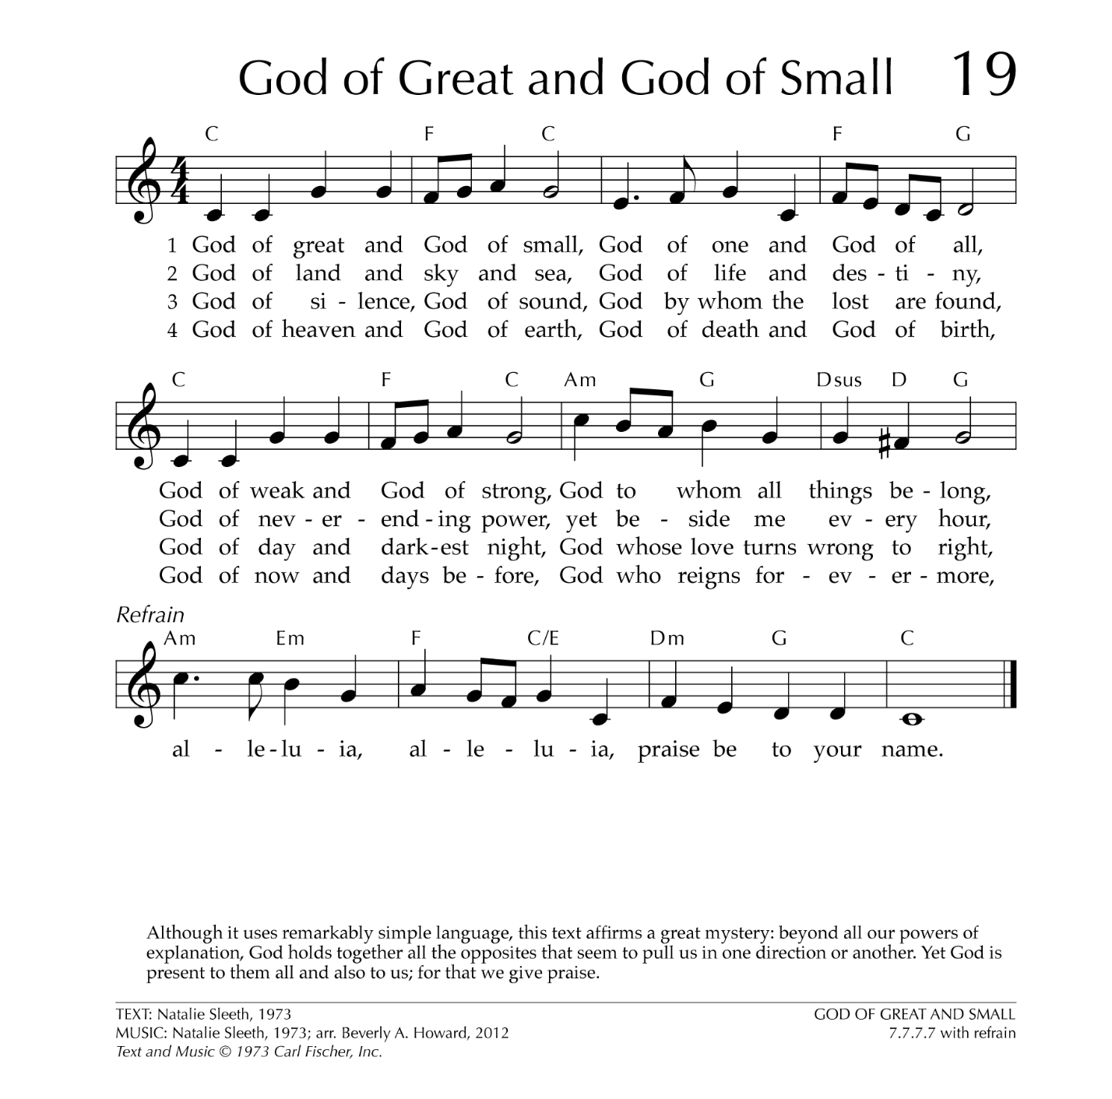

**\*Passing the Peace**

The peace of Christ be with you. **And also with you.**

We Hear God’s Word

**Time for All God’s Children**

**Prayer of Illumination**

**Gospel Reading**Luke 15:1-7

Now all the tax collectors and sinners were coming near to listen to him. 2And the Pharisees and the scribes were grumbling and saying, “This fellow welcomes sinners and eats with them.”

3So he told them this parable: 4“Which one of you, having a hundred sheep and losing one of them, does not leave the ninety-nine in the wilderness and go after the one that is lost until he finds it? 5And when he has found it, he lays it on his shoulders and rejoices. 6And when he comes home, he calls together his friends and neighbors, saying to them, ‘Rejoice with me, for I have found my lost sheep.’ 7Just so, I tell you, there will be more joy in heaven over one sinner who repents than over ninety-nine righteous persons who need no repentance.

This is the Word of the LORD. **Thanks be to God.**

**Sermon** Rev. Elliot Gargus

**“Lost & Found”**

*Rejoice with me, for I have found my sheep that was lost.*

*Luke 15:6*

We Respond to God’s Word

**Prayers of the People and the Lord’s Prayer**

Trusting in God’s promises, let us pray for the world, the church, and our needs, saying,

Holy God, **hear our prayer.**

**Our Father who art in heaven, hallowed be thy name. Thy kingdom come, thy will be done, on earth as it is in heaven. Give us this day our daily bread, and forgive us our debts as we forgive our debtors; and lead us, not into temptation, but deliver us from evil. For thine is the kingdom and the power and the glory, forever. Amen.**

**Call to Offering**

**\*Offertory Hymn #802**St. Columba

**“The King of Love My Shepherd Is”**

(verses 1, 2, 4, 6)

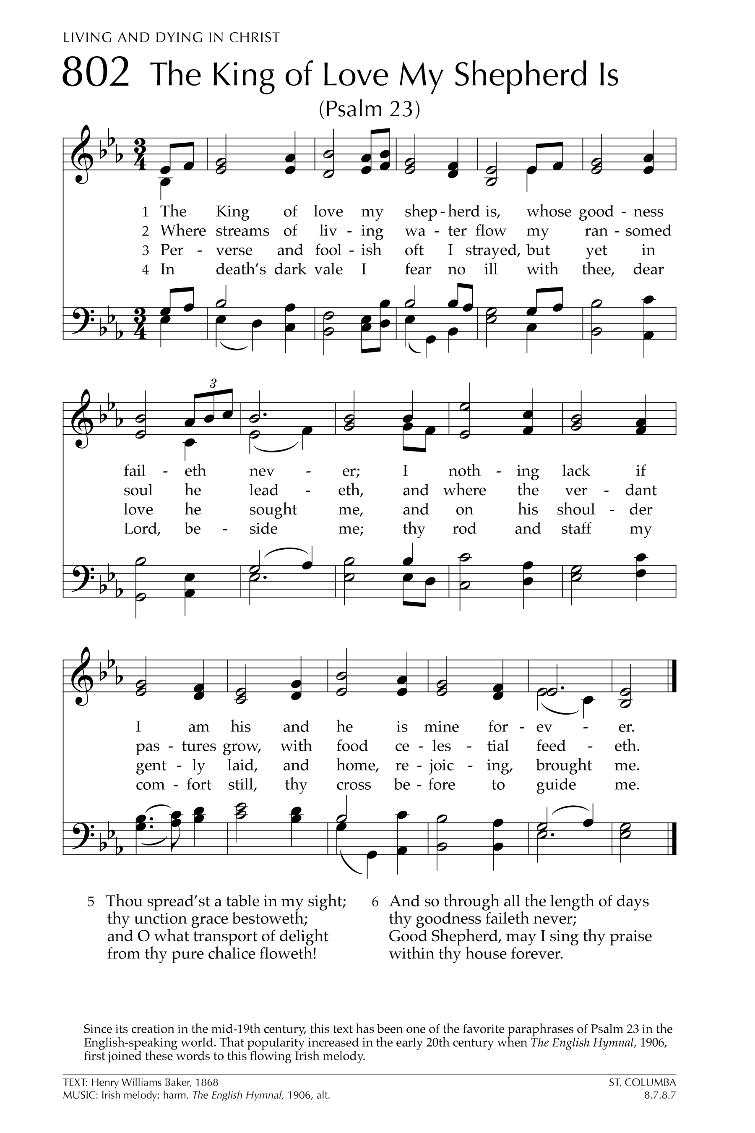

**\*Doxology**

***Praise God, from Whom all blessings flow, Praise Him, all creatures here below;***

***Praise Him above, ye heavenly host; Praise Father, Son, and Holy Ghost. Amen.***

**\*Prayer of Thanksgiving**

**\*Affirmation of Faith**

**We believe in a seeking God, a with-us and before-us God, a chasing-after-us God. We believe that no matter where we wander or what mountains we climb, *this* God – the God who walked the streets of Jerusalem, shook hands with lepers, patted children on the head, and told stories of love – is always close at hand.**

**So, on good days and the hard days, on the mountains and in the valleys, we believe that we are always being found. Thanks be to God for a love like that. Amen.**

**\*Hymn #541“God Be with You ‘til We Meet Again”**Randolph

**Charge and Benediction**

**Postlude**

[*All stand as they are able.]

*The sanctuary flowers this Sunday are given by Arthur & Kathy Gillespie*

*in memory of Betty Manning Gossom.*

**Serving Today at Westminster**

Piano: Amy Fennell

Vocalist: Joyce and Spears Alexander

Liturgist: Elizabeth Watkins

Host: Mary Anne and Richard Wilson

Adult Sunday Study: Bill Jacobs

Children’s Sunday School: Kathy Gillespie

**Today at Westminster**

Sunday Study 9:00 am Choir Room *(Adults)*

Sunday School 9:00 am Children’s Wing *(Children and Youth)* Worship 10:00 am Sanctuary

Children’s Nursery 10:00 am Sanctuary and Children’s Wing

**This Week at Westminster**

Office Hours: 9:00 – 1:00 M-Th

BEMA Discussion Group 6:00 – 7:00 Monday Joe Gettys Classroom

Crazy Heart Meditation 6:00 pm Tuesday Fellowship Hall

Brown Bags and Books 6:00 – 7:30 Wednesday Joe Gettys Classroom

Crazy Heart Meditation 10:00 am Saturday Fellowship Hall

**Next Sunday, April 6, 2025 – Fifth Sunday in Lent**

Sunday Study 9:00 am Choir Room *(Adults)*

Sunday School 9:00 am Children’s Wing *(Children and Youth)* Worship and Communion 10:00 am Sanctuary

Children’s Nursery 10:00 am Sanctuary and Children’s Wing

**ANNOUNCEMENTS**

**Guest Preacher, Elliot Gargus** We are delighted to welcome one of our own to the pulpit today. Elliot is an ordained minister through the United Church of Christ and a graduate of Columbia Theological Seminary in Atlanta. Previously, they worked as a chaplain in a children's hospital. Elliot is currently working on a Master's degree in Counseling, and hopes to work in the intersection of faith and mental health after graduation. Elliot lives with husband, Michael, and two cats, Blue and Sammy.

**Study Opportunities at Westminster**

**Sunday Adult Study:** Bill Jacobs will continue our Sunday Study Lent Series: “The God We Can Know: Exploring the “I Am” Sayings of Jesus by Rob Fuquay, chapter 5: “I Am the True Vine.”

**Brown Bags and Books** continues our discussion of the WPC’s Lenten Devotion Book, “Everything (in) Between.”

**Easter Egg Hunt:** Bring all the children in your life to the Courtyard on Sunday, April 13 at 3:00 pm for an Easter Egg Hunt! Have a joyful afternoon discovering hidden treasures in the churchyard!

|  |  |  |
| --- | --- | --- |
| **WESTMINSTER PRESBYTERIAN CHURCH**  *An Inclusive Community of Faith*  *United by Our Belief in and Commitment to Jesus Christ*  Office Hours: M-Th 9:00 a.m. – Noon Office Phone: 864.229.3595  www.wpcgnwd.org wpcgwd1@gmail.com | | |
| Clerk of Session | Treasurer | Office Manager |
| Claire Kuhl | Len Bornemann | Charleston Warner |
|  |  |  |
|  | **RULING ELDERS** |  |
| Class of 2025 | Class of 2026 | Class of 2027 |
| Tina Corley | Laine Horowitz | Luke Christie |
| Rob Graves | Richard Wilson | Bill Kimler |
|  | | |
| **Rev. Caroline Vinson Dennis, pastor** | | |
| 317.777.1487 | | |
| ***Sunday Study 9:00 a.m. Church Service: 10:00 a.m.*** | | |
| CCLI License #2724601 and #20189191 | | |